LAB 1 Submission

Name: Anurup R Krishnan​
Roll NO: CB.SC.U4CSE23559

1) About the Use Case

Social Cues is a small React app that helps learners practice everyday social scenarios. Users choose a scenario, read a short context, and select responses step-by-step to receive feedback. The goal is to improve social communication, decision-making, and confidence in real-life interactions through guided practice.

2) Upload the completed Lab 1 in GitHub

- Repository URL: https://github.com/Anurup-R-Krishnan/Social-Script

- Date uploaded: 5/2/26

3) Extension to Lab 1

a) Add one more webpage (extended concept with forms)

Planned page: Practice Reflection Planner

- Purpose: Allow users to plan and reflect on practice sessions for scenarios.

- Fields: Student name (optional text), Scenario (dropdown), Practice goal (text), Practice duration (number), Practice mode (radio), Include teacher note (checkbox), Reflection notes (textarea)

- Validations: Required scenario and goal (min 3 chars), duration 5-30 mins.

Concepts to Implement (including Hooks and Routing)

- Routing: View-based navigation with state (home, player, parent, settings, reflection).

- Hooks: useState, useEffect, custom useLocalStorage hook.

- Forms: Controlled components with validation, various input types (text, select, number, radio, checkbox, textarea).

Contribution Table

Add code proof links or screenshots for each concept below.

Concept | Screenshot
Function component | 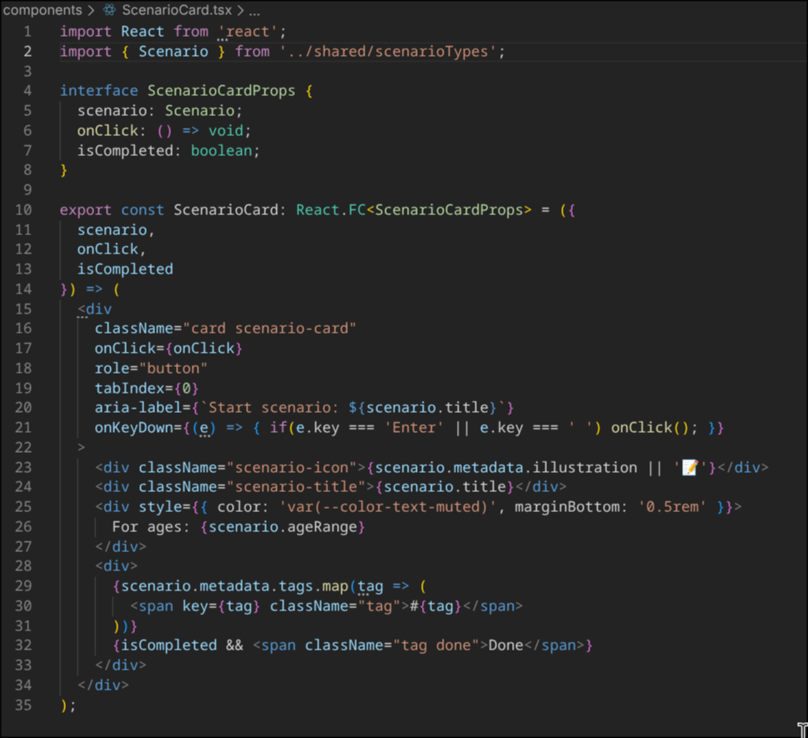
Class Component | Not used
Event | 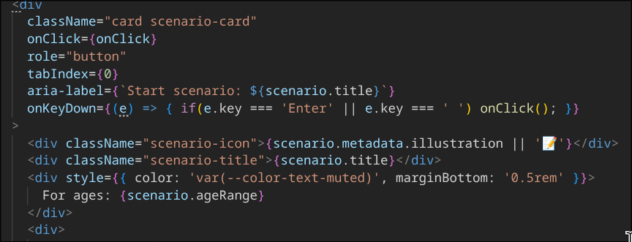
State Management | 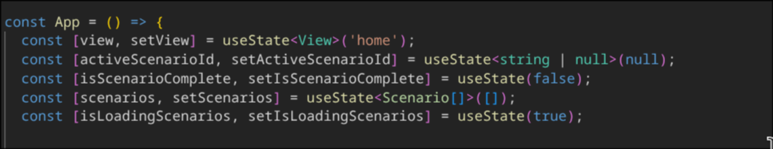
Stateless Component | 
Forms | 